Amazon Web Services
Amazon S3
Amazon S3 (Simple Storage Service) in AWS is a cloud-based object storage service. Amazon S3 is widely used because it provides secure, scalable, and durable cloud storage for almost any kind of data.
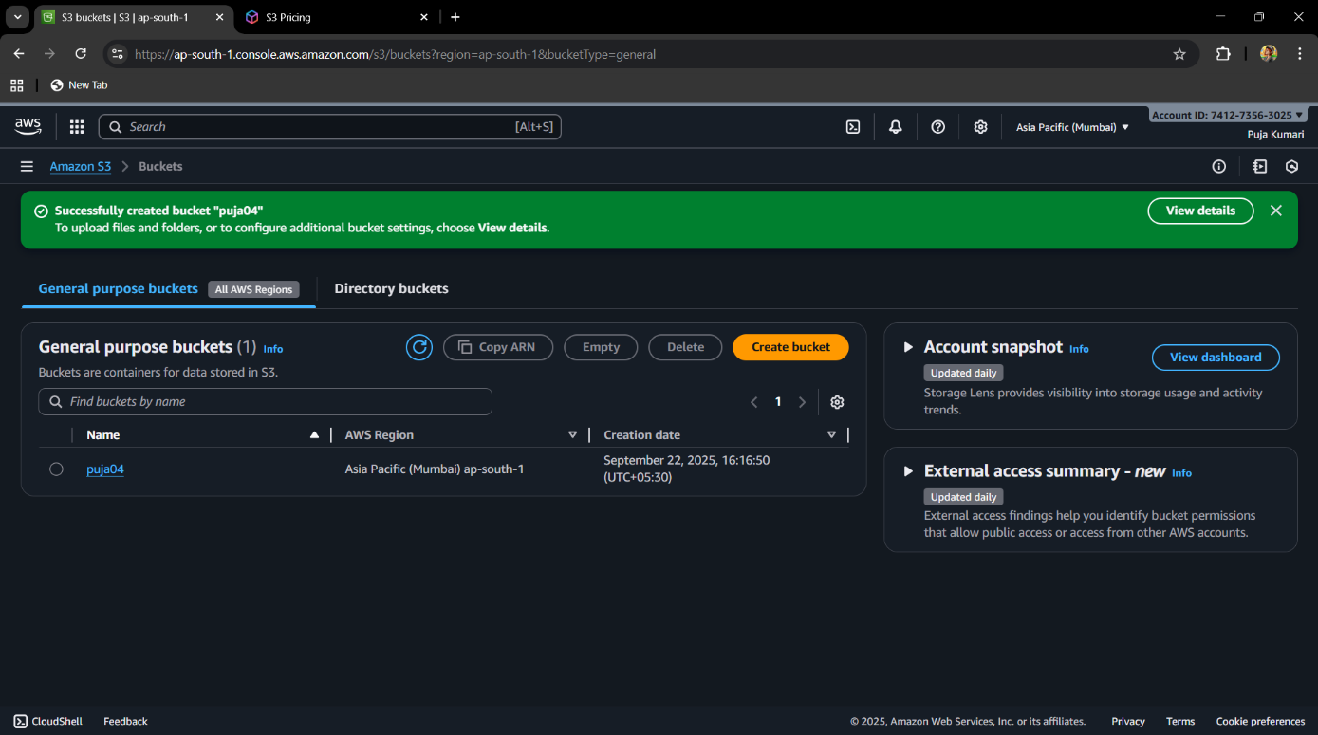
Screenshot-1

Explaination :- Here a bucket is created. A bucket is like a top-level container where we keep our files. Each bucket has a unique name in AWS. Here, my bucket name is “puja04”.

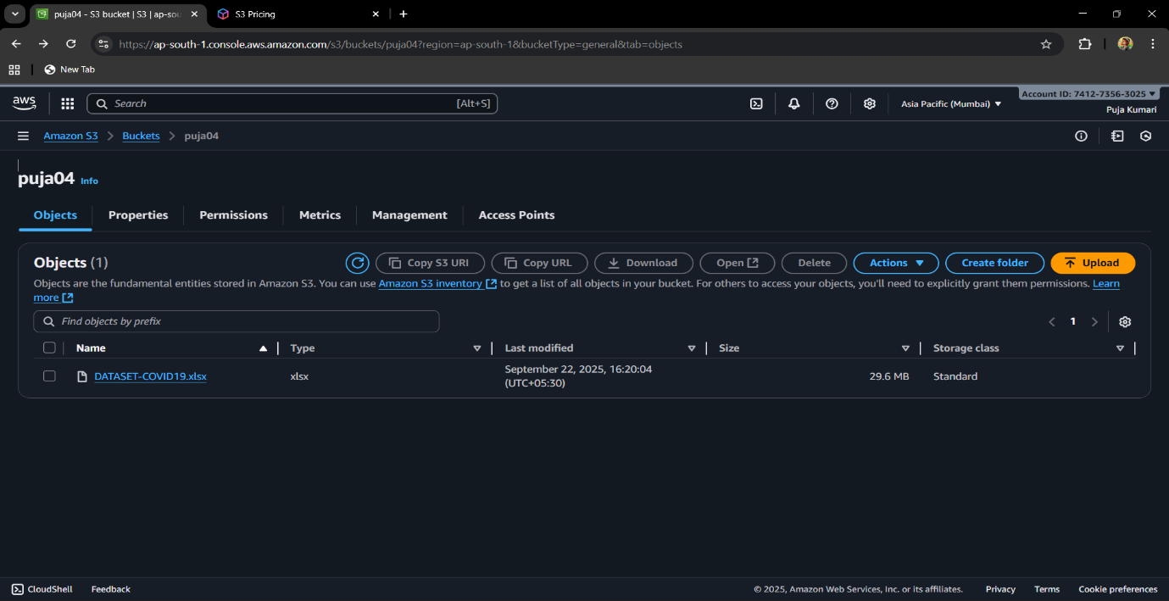
Screenshot -2

Explaination
Inside the bucket, clicked the Upload button and chose the file which is to be store—in this case, DATASET-COVID19.xlsx. After uploading, the file appears under the Objects tab, where we can see its details such as name, type, size (29.6 MB), last modified date (September 22, 2025, 16:20:04), and storage class (Standard). The S3 console also provides several management options like Copy S3 URI, Copy URL, Download, Open, Delete, or creating folders for better organization. These steps allow us to securely store, access, and manage our files in the cloud using Amazon S3.

